**PROBLEM STATEMENT:**

The healthcare industry often faces challenges integrating various stakeholders into a single streamlined system including doctors, patients, labs, pharmacies, administrators, and insurers. Inefficiencies arise in managing patient information, scheduling appointments, processing prescriptions, and coordinating lab tests, leading to delays and errors in service delivery. Financial operations, such as billing and insurance claim processing, often need more automation, increasing the risk of discrepancies. Administrators need help to handle employee management, funding requests, and organization-level data across different networks. Security concerns further complicate matters, with inadequate mechanisms for managing user authentication and role-based access. A centralized database is needed to securely store and retrieve patient records, test results, prescriptions, and billing information. Communication between entities, such as labs and insurance agents, could be more cohesive, creating bottlenecks in the workflow. A unified platform limits collaboration between government bodies, healthcare providers, and enterprises. A scalable ecosystem is needed to provide real-time access and updates while ensuring the privacy and security of sensitive data. The objective is to design a healthcare management system with a robust database that integrates all these functionalities and provides seamless stakeholder interactions.

**SOLUTION:**

To address the challenges outlined in the problem statement, a Comprehensive Healthcare Management System (CHMS) is proposed. The solution integrates key functionalities across all stakeholders while ensuring scalability, security, and efficiency. Below is the detailed plan:

1. **Role-Based System Architecture:**
   * Implement distinct roles for stakeholders, including Doctors, Patients, Lab Assistants, Government Officials, Insurance Agents, Pharmacists, Accountants, and Administrators.
   * Each role has tailored functionalities, such as doctors managing appointments, lab assistants processing test results, and pharmacists handling prescription data.
2. **Centralised Enterprise and Network Management:**
   * Provide a centralized system for managing healthcare enterprises and networks.
   * Allow system administrators to create, modify, and delete enterprise networks while overseeing network operations.
3. **Seamless Communication and Workflow Management:**
   * Design a request-handling mechanism to connect stakeholders. For example:
     + Doctors can assign lab tests to lab assistants.
     + Insurance agents can process claims submitted by accountants.
     + Patients can request appointments and prescriptions via the system.
   * Automate task assignments to minimize delays and miscommunication.
4. **Secure User Authentication and Data Management:**
   * Introduce a secure Login System with password encryption and multi-factor authentication.
   * Implement role-based access controls (RBAC) to ensure sensitive data is accessed only by authorized personnel.
   * Store and manage all data in a centralized database with encryption to ensure privacy and regulatory compliance (e.g., HIPAA).
5. **Integrated Appointment, Billing, and Insurance Management:**
   * Develop appointment scheduling, billing, and insurance processing to reduce manual work and errors.
   * Enable accountants to create and process bills, while insurance agents handle claims and requests in a streamlined manner.
6. **Doctor and Patient Collaboration:**
   * Create a patient portal for accessing medical histories, viewing prescriptions, and requesting follow-ups.
   * Allow doctors to view patient histories, prescribe treatments, and monitor lab results in real-time.
7. **Lab and Pharmacy Management:**
   * Provide lab assistants with tools for assigning and processing tests and submitting results directly to doctors or patients.
   * Enable pharmacists to handle prescription fulfillment and generate reports for medication usage trends.
8. **Administrative Oversight:**
   * Equip administrators with tools for managing employees, organizations, and financial requests.
   * Enable seamless integration of funding requests into the enterprise’s financial workflows.
9. **Scalable and Interoperable System:**
   * Design the system to support multiple healthcare enterprises and integrate with third-party services, such as government health programs or external insurance providers.
   * Utilize cloud-based solutions to ensure scalability for growing user demands.

By implementing this solution, the healthcare system can bridge operational gaps, improve stakeholder collaboration, and enhance patient care, ensuring a modern, efficient, and secure healthcare ecosystem.

3. **High Level Component Diagram & Ecosystem hierarchy (UML)**

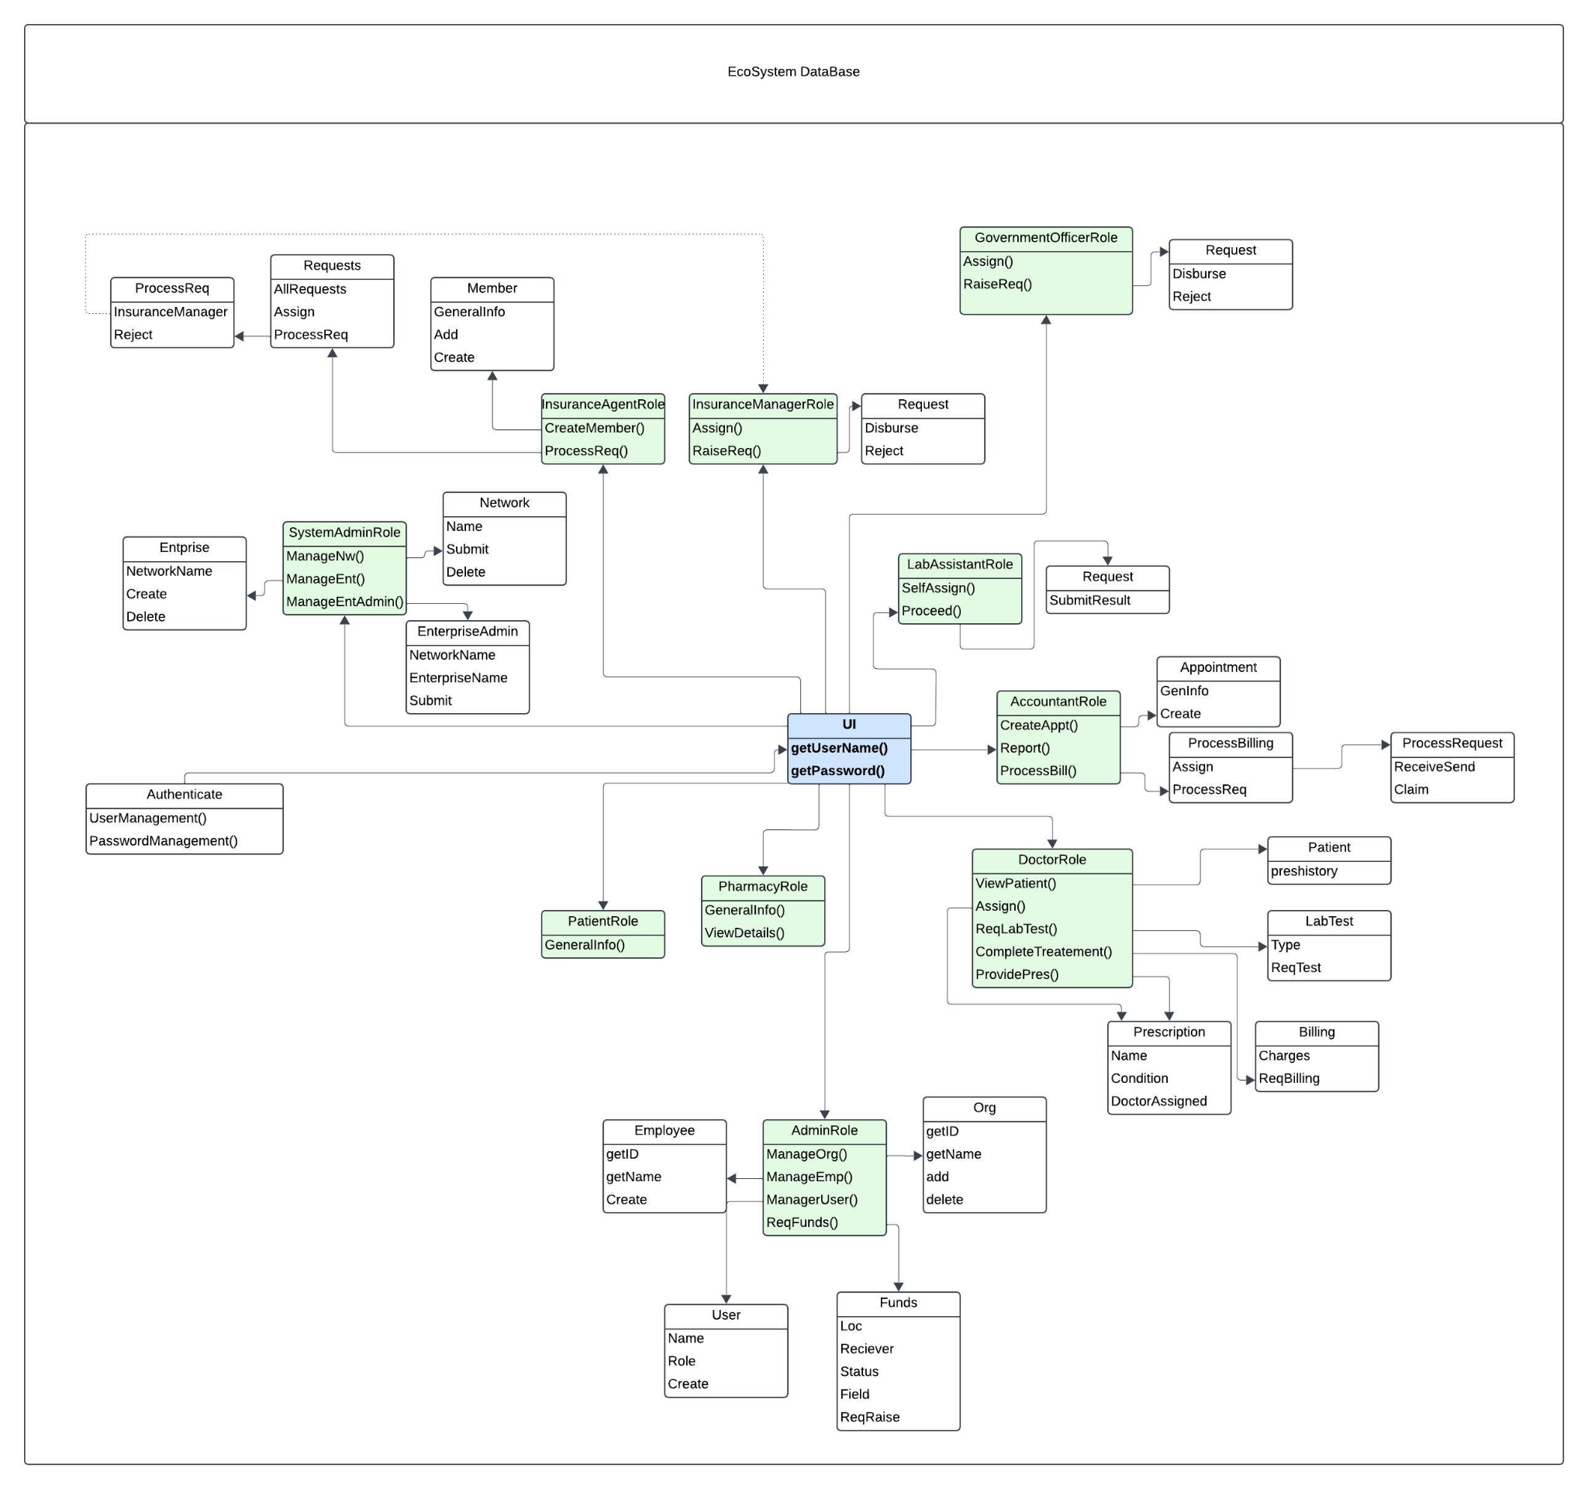

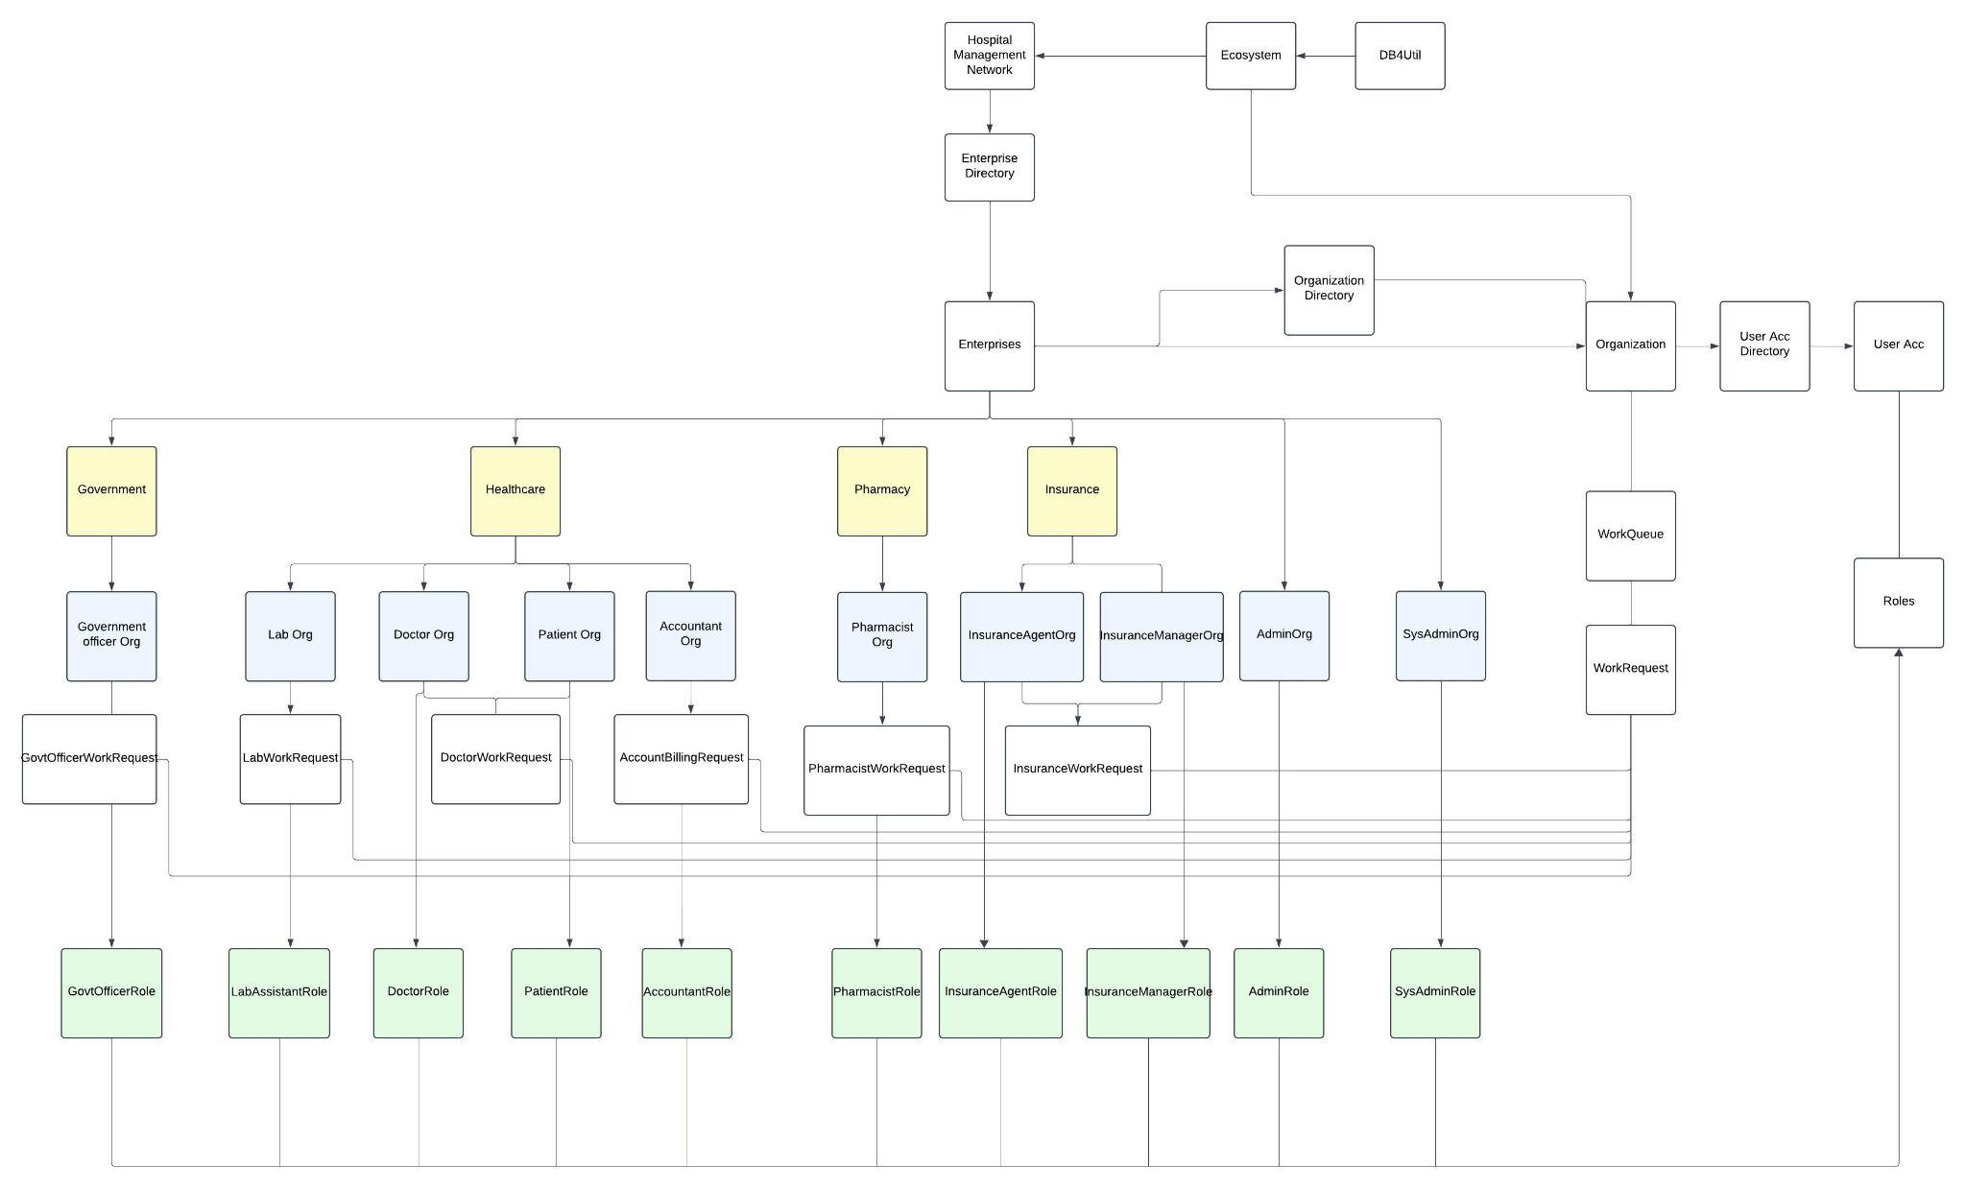

**Network -** Hospital Management System

**Enterprise -** Government, Healthcare, Pharmacy, Insurance

**Organizations-** Government Org, Lab Org, Doctor Org, Insurance Agent Org, Insurance Manager Org, SysAdmin Org, Admin Org, PharmacistOrg, Accountant Org, Patie sntOrg

**Roles-**Government Role, Lab Role, Doctor Role, Insurance Agent Role, Insurance Manager Role, SysAdmin Role, Admin Role, Pharmacist Role, Accountant Role, Patient Role

### **4. Use Cases**

#### A. Patient Lifecycle

* The accountant creates an appointment request.
* Doctors assign lab tests and provide prescriptions post-consultation.
* The Lab Assistant receives a test from Doctor and submits the results..
* Billing and insurance claims are processed for payments.

#### B. Doctor Collaboration

* Doctors can assign tasks to lab assistants, collaborate with pharmacists, and request billing to ensure seamless care delivery.

#### C. Insurance Claim Workflow

* Accountants raise claims after processing billing.
* Insurance agents validate and process claims.
* Insurance managers approve and disburse funds.

#### D. Administrative Oversight

* Admins oversee employee data, assign roles, and manage enterprise funding.

#### E. Government Official Workflow

* Admin raises a request to government official for funding.
* Government official approves or rejects the funding request.